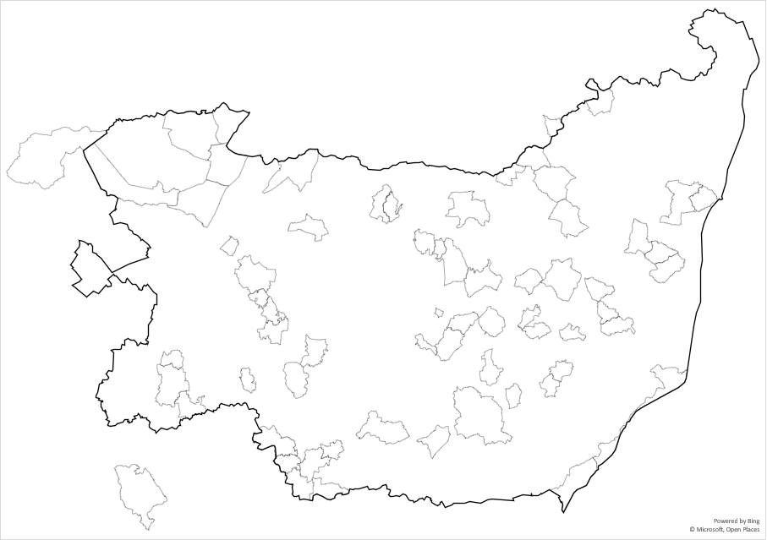

• < Lt Glemham

• < Blaxhall

Nayland > ••

**Source Distribution Map**

Texts [1] to [64]

Diaries, Societies, Memoirs, Books, Parliamentary Papers

•• < Wickham Market

• < Laxfield

• < Washbrook

• < Stradishall

• < Butley

Charsfield > •

• < Felixstowe

Clare > •

Elveden > •

Bury St Edmunds > •••••

• < Boxford

Hadleigh > •••

Lt Cornard > •

Gt Cornard > •

Sudbury > •

Hundon > •

Bradfield > •

Hengrave > •

Brandon > •

Cottenham > •

Mildenhall > •

• < Bungay

• < Gt Glemham

• < Earl Soham

••• < Framlingham

• < Walberswick

•• < Blythburgh

•• < Yoxford

• < Fressingfield

• < Helmingham

• < Monewdon

• < Assington

• < Hardwick

• < Nowton

••• < Woodbridge

• <Coddenham

Crowfield > •

Earl Stonham > •

Stowmarket > •

• • < Middleton

• < Melton

• < Theberton

Wickham Skeith > •

• < Playford

Witnesham > •

Debenham > •

• < Icklingham

• < Euston

• < Orford

Wetheringsett > •

Wortwell > ••

Weybread > •

Syleham > •

Rickinghall > •

Eye > •

Ipswich > •••

Stanstead> •

•• < Lavenham

Thorpe Morieux > •

Ixworth > •

Finchingfield > •